# *Lab 9 – State Machine Diagrams*

Date assigned: Monday, March 13, 2016

Date due: **Monday, March 13, 2016, 14:50**

**Learning Objectives**

Upon successful completion of this lab exercise, the student will be able to:

* Practice with State Machine Diagrams

Lab Set Up

1. Use Lucidchart to create diagrams and paste them in this document. Rename it to YourUserName_E21_L09_State_Machine_Diagrams.docx and submit to Moodle by end of lab.

To do:

1. Draw the behavioral state machine for the life cycle of an instance of a Book class in a library. The states identified for a book object include Available, Checked Out, Overdue, Requested, Damaged, and Being Repaired. Certain transitions probably do not apply; for instance, it makes no sense to have a book to go from a repaired state to a damaged state. However, going from a damaged state to a repaired state makes sense. Nor does it make sense for a book to go from an available state directly to an overdue state. However, the converse makes sense. Note that a book might be too damaged; in which case we transition to the final pseudo state.

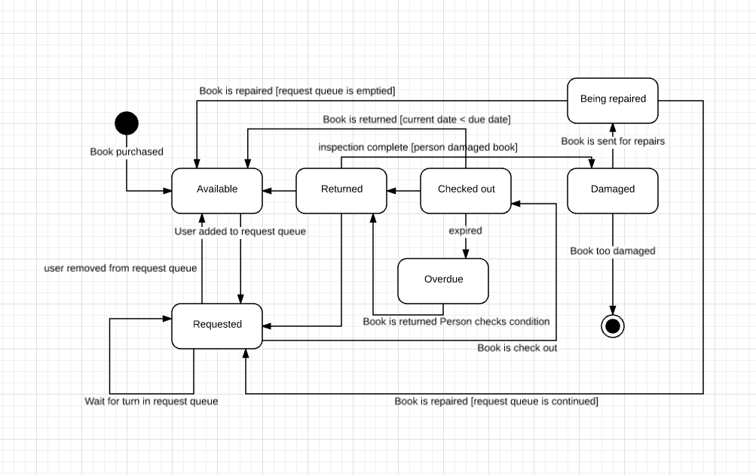

1. Draw a state machine diagram for the states that an assignment goes through from the time it is assigned by the instructor, to a draft being completed, the draft assignment being reviewed until it is correct, the assignment being submitted, marked and returned. Remember to use triggers and behaviours for the transitions between the states and guard conditions for when the transitions will take place.

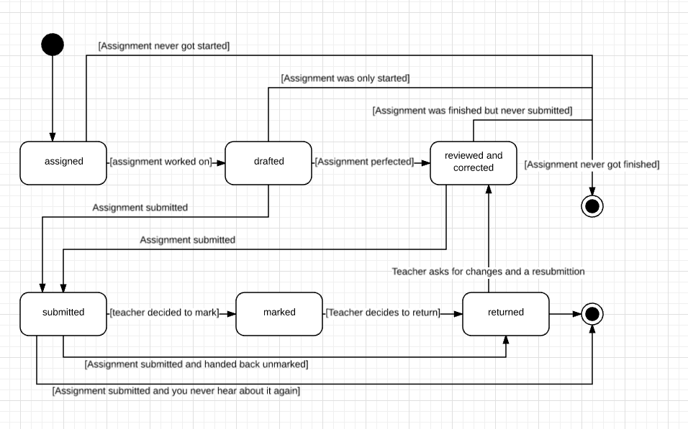

1. Reservations are made for repairs of vehicles. The vehicle is delivered and waits in the dock until repair can commence. Repair can commence at any time. During repair new parts may be needed and the vehicle may have to wait for the parts to arrive. When repairs are completed a test drive is organized. Following the test drive, if the vehicle does not pass the test drive, more repairs are needed. If not more repairs the vehicle will become ready to be picked up. Two days later the vehicle is picked up by its owner.
2. Early video games extensively used state machines such as this one for a platformer:

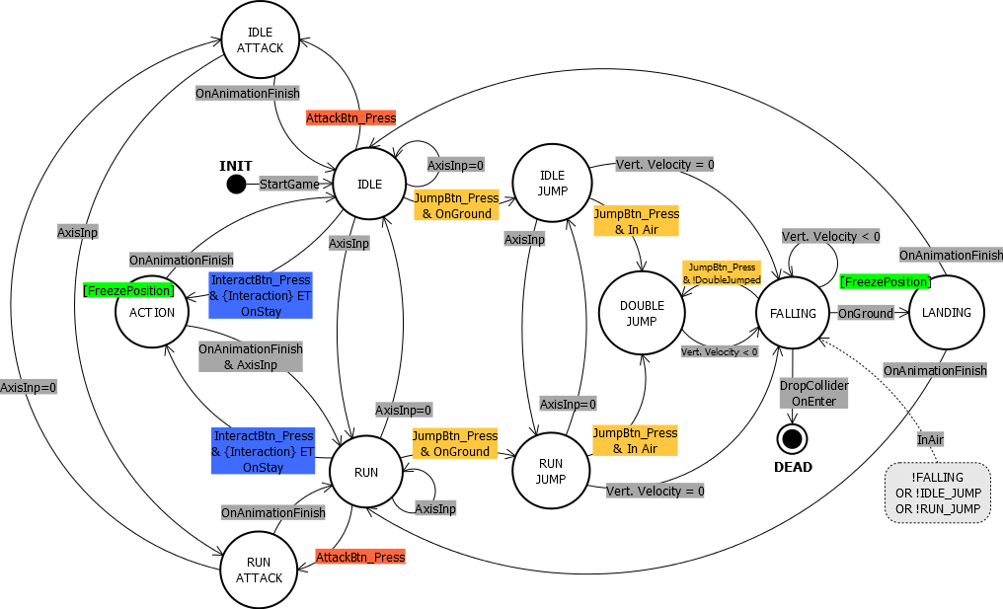

Read [this article](http://gameprogrammingpatterns.com/state.html). (You can stop when you get to the section “The State Pattern”. The rest is just implementation details.)

Answer the following:

Define FSM, and what is meant by “finite” and “state”?

What do the nodes of a FSM diagram represent?

What to the connections between the nodes represent?

Examine the code at the top of the article (with bugs) and the example provided in [Enum and Switches](http://gameprogrammingpatterns.com/state.html#enums-and-switches). What is the benefit to going to the state-driven model? What would be easier to read in order to understand the game, the code (enum/switch version) or the State machine diagrams?

1. Assessment
2. What did you learn in completing this lab?
3. What did you have difficulty with?
4. What did you do well?
5. How many hours did you spend in completing this lab?
6. What took you the most time?

Mark breakdown

|  |  |
| --- | --- |
| **Part A** |  |
| Book FSM | 10 |
| **Part B** |  |
| Assignment FSM | 10 |
| **Part C** |  |
| Reservation FSM | 10 |
| **Part D** |  |
| Games FSM Analysis | 5 |
| Self-assessment and properly handed in, English | 5 |

To Submit

Copy the following files to the Moodle directory for this course:

* YourUserName_E21_L09_State_Machine_Diagrams.docx